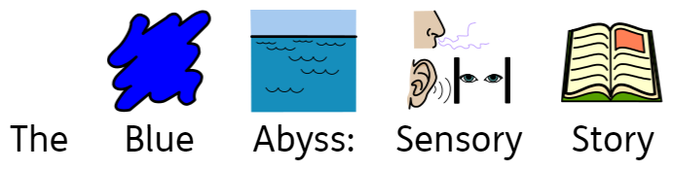

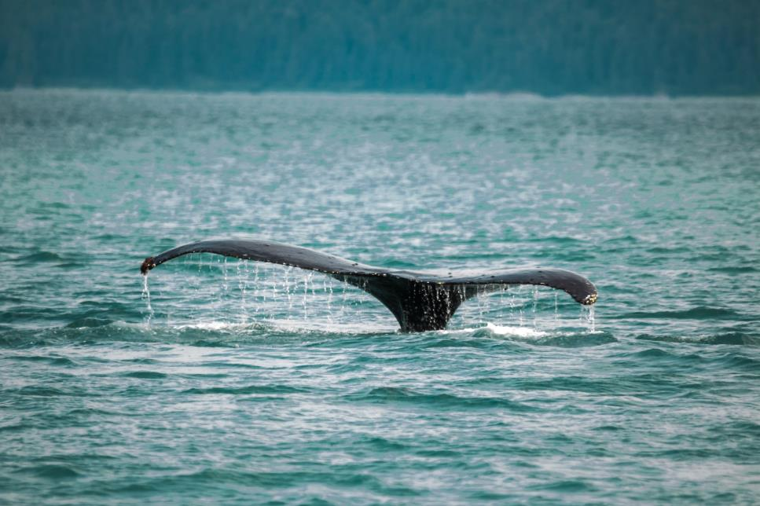

Joe White
This is a beach with water and sand.
Can you feel the grains rough in your hand?

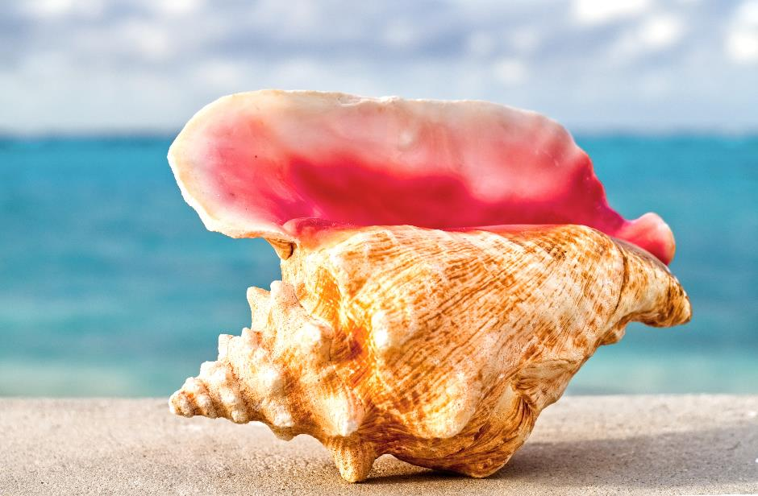
This shell was washed up, hold it up to your ear.
The wind or the sea, what can you hear?

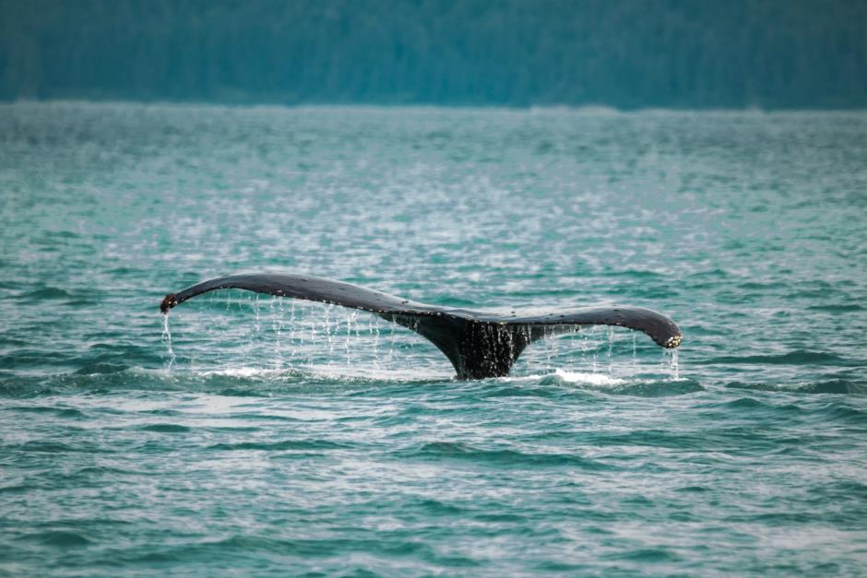
There in the distance, a sea creatures’ tail!
Can you feel the bumpy skin of the whale?
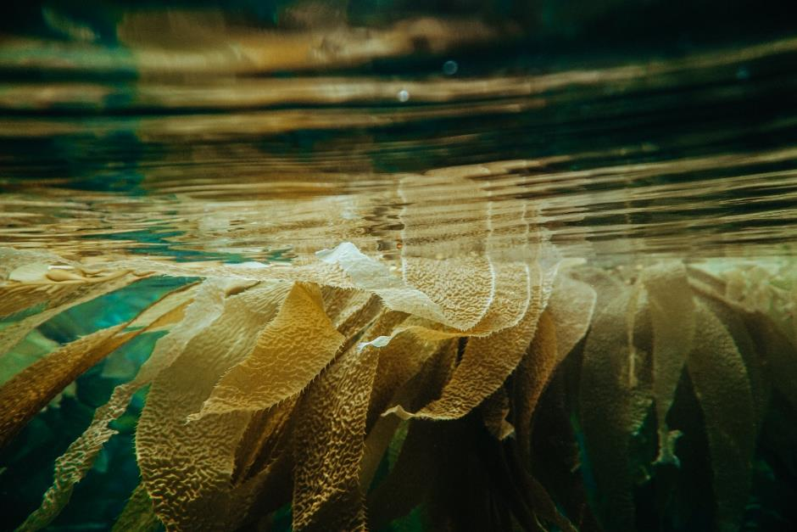

Wade into the sea something wet, slimy, and cold.
Can you feel the seaweed that’s slippery to hold?

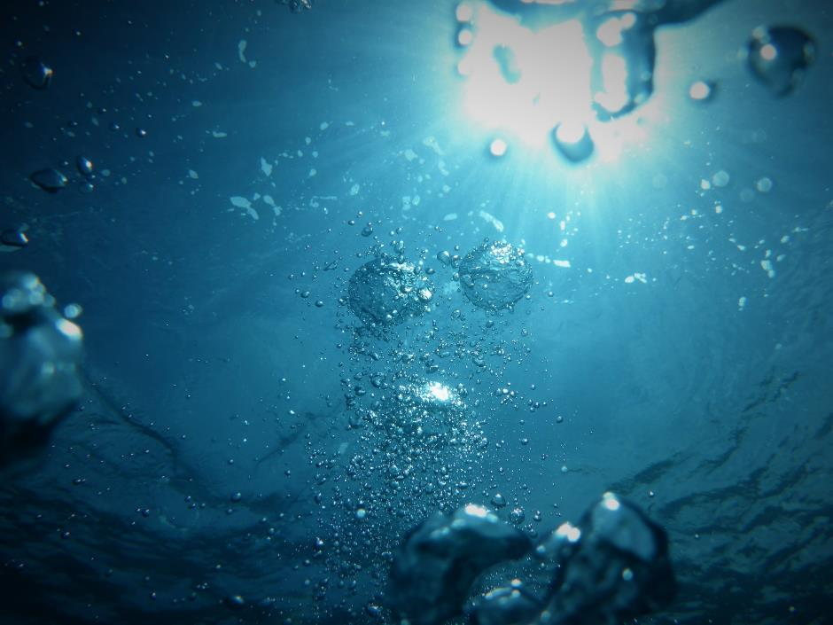
The water is clear and the water is bright.
Can you catch the bubbles shining in the light?
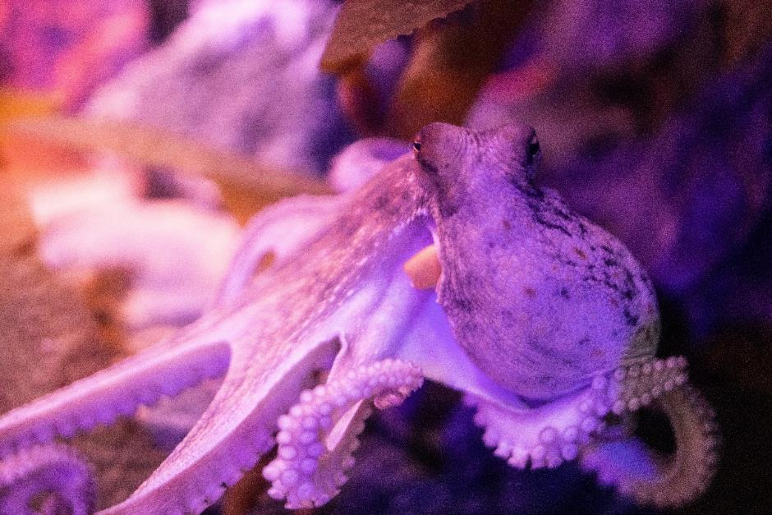
Deep down in the sea an Octopus swims.
Watch as it curls and stretches 8 rubbery limbs.
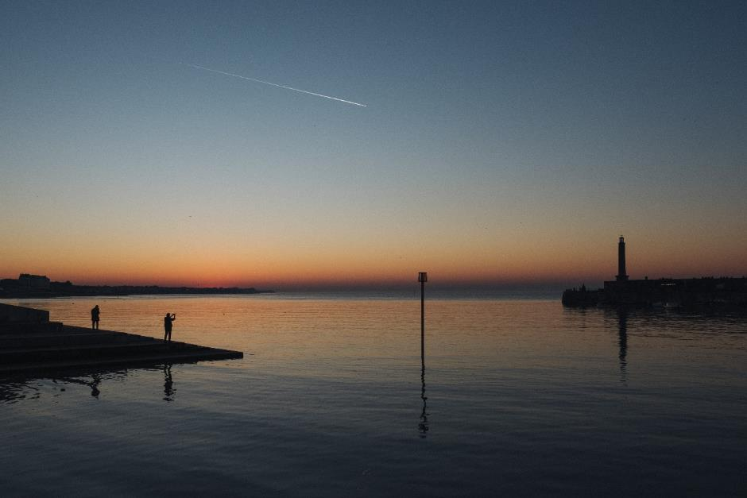
Now the sun is going down, soon it will be dark.
Listen to the seagulls and watch out for the…..

SHARK!

