|  |  |
| --- | --- |
| **Name** |  |
| **Learning Objective** | Identify where each food item should be stored |
|  |
| **Date** |  |

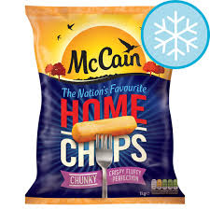 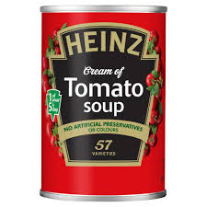

Cupboard

Fridge

Freezer

Cupboard

Fridge

Freezer

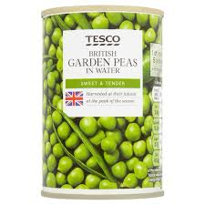 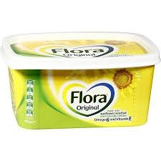

Cupboard

Fridge

Freezer

Cupboard

Fridge

Freezer

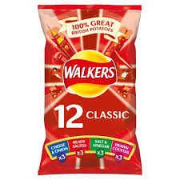 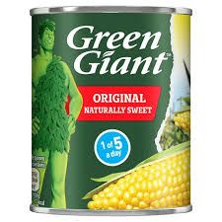

Cupboard

Fridge

Freezer

Cupboard

Fridge

Freezer

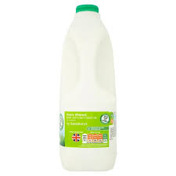 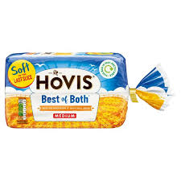

Cupboard

Fridge

Freezer

Cupboard

Fridge

Freezer

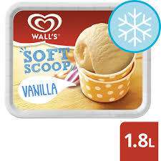 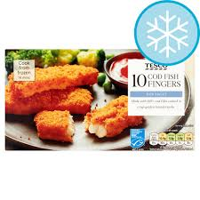

Cupboard

Fridge

Freezer

Cupboard

Fridge

Freezer

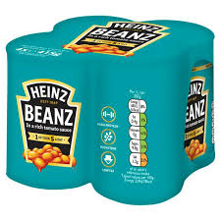 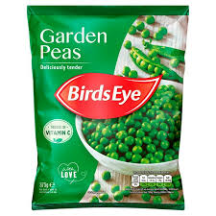

Cupboard

Fridge

Freezer

Cupboard

Fridge

Freezer

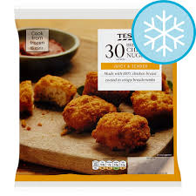 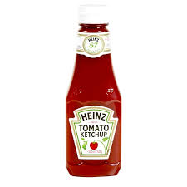

Cupboard

Fridge

Freezer

Cupboard

Fridge

Freezer

|  |  |
| --- | --- |
| **Name** |  |
| **Learning Objective** | Label the main features and appliances in the kitchen |
|  |
| **Date** |  |

**Extractor fan tap microwave cupboard toaster microwave fridge freezer**

|  |  |  |  |  |  |  |
| --- | --- | --- | --- | --- | --- | --- |
|  |  |  |  |  |  |  |

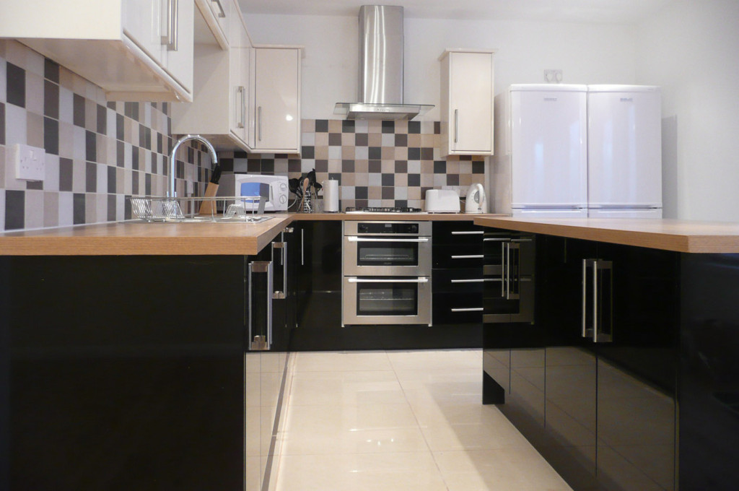

|  |  |  |  |  |  |  |
| --- | --- | --- | --- | --- | --- | --- |
|  |  |  |  |  |  |  |

|  |  |
| --- | --- |
| **Name** |  |
| **Learning Objective** | Label each of the Kitchen utensils |
|  |
| **Date** |  |

**cheese grater colander measuring jug tongs**

**potato masher wooden spoon spatula mixing bowl**

**can opener whisk sieve ladle**

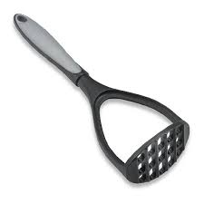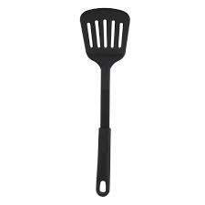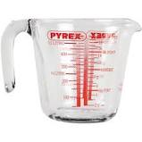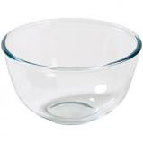

|  |  |  |  |  |  |  |
| --- | --- | --- | --- | --- | --- | --- |
|  |  |  |  |  |  |  |
|  |  |  |  |  |  |  |

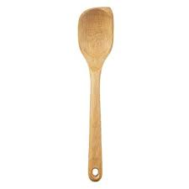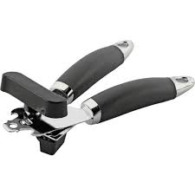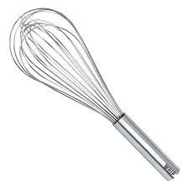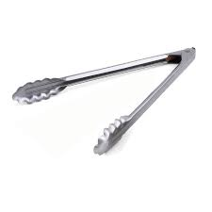

|  |  |  |  |  |  |  |
| --- | --- | --- | --- | --- | --- | --- |
|  |  |  |  |  |  |  |
|  |  |  |  |  |  |  |

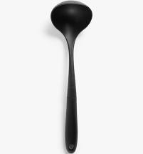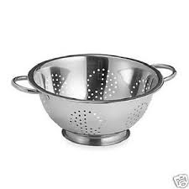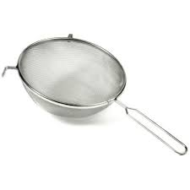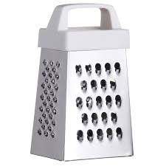

|  |  |  |  |  |  |  |
| --- | --- | --- | --- | --- | --- | --- |
|  |  |  |  |  |  |  |
|  |  |  |  |  |  |  |

|  |  |
| --- | --- |
| **Name** |  |
| **Learning Objective** | Label each of the items used for cleaning |
|  |
| **Date** |  |

**mop and bucket scrubbing brush surface spray washing up liquid**

**floor cleaner washing powder sponge dustpan and brush**

**tea towels rubber gloves laundry basket cloth**

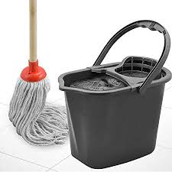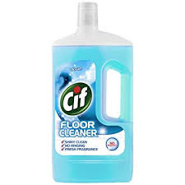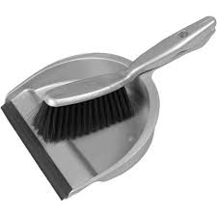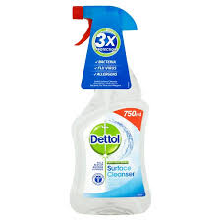

|  |  |  |  |  |  |  |
| --- | --- | --- | --- | --- | --- | --- |
|  |  |  |  |  |  |  |
|  |  |  |  |  |  |  |

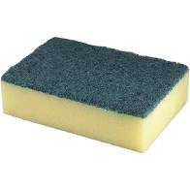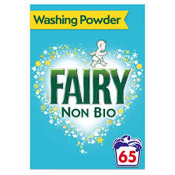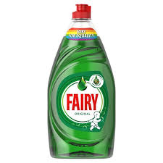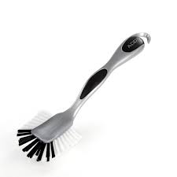

|  |  |  |  |  |  |  |
| --- | --- | --- | --- | --- | --- | --- |
|  |  |  |  |  |  |  |
|  |  |  |  |  |  |  |

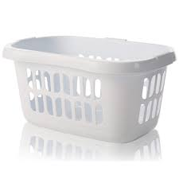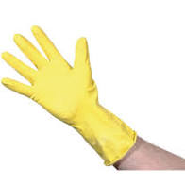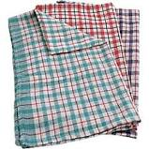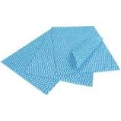

|  |  |  |  |  |  |  |
| --- | --- | --- | --- | --- | --- | --- |
|  |  |  |  |  |  |  |
|  |  |  |  |  |  |  |

|  |  |
| --- | --- |
| **Name** |  |
| **Learning Objective** | Name and describe each item used for cleaning the kitchen |
|  |
| **Date** |  |









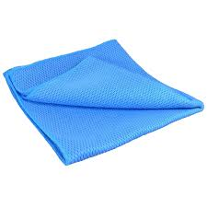

|  |  |
| --- | --- |
| **Name** |  |
| **Learning Objective** | Name and describe each appliance found in the kitchen |
|  |
| **Date** |  |

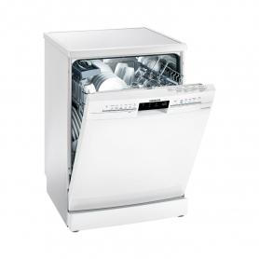

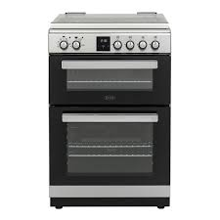

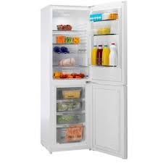

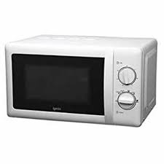

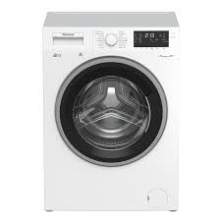

|  |  |
| --- | --- |
| **Name** |  |
| **Learning Objective** | Name and describe items used when having a shower |
|  |
| **Date** |  |

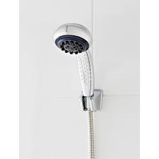

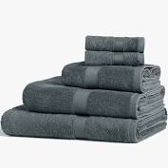

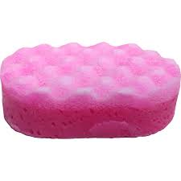

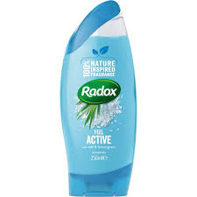

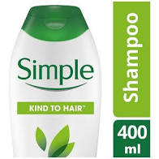

|  |  |
| --- | --- |
| **Name** |  |
| **Learning Objective** | Name and describe each item used for washing dirty clothes. |
|  |
| **Date** |  |



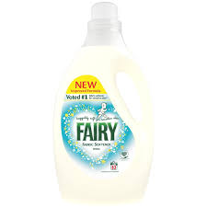





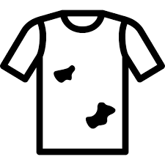

|  |  |
| --- | --- |
| **Name** |  |
| **Learning Objective** | Name and describe each item used for washing up (dishes) |
|  |
| **Date** |  |











|  |  |
| --- | --- |
| **Name** |  |
| **Learning Objective** | Name and describe item used when cleaning your teeth |
|  |
| **Date** |  |

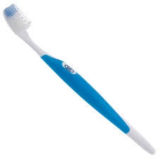

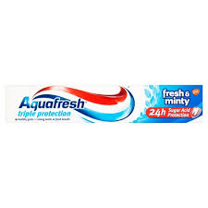

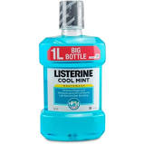

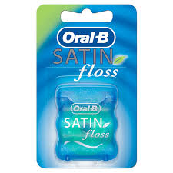

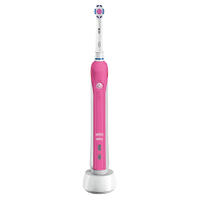

|  |  |
| --- | --- |
| **Name** |  |
| **Learning Objective** |  |
|  |
| **Date** |  |